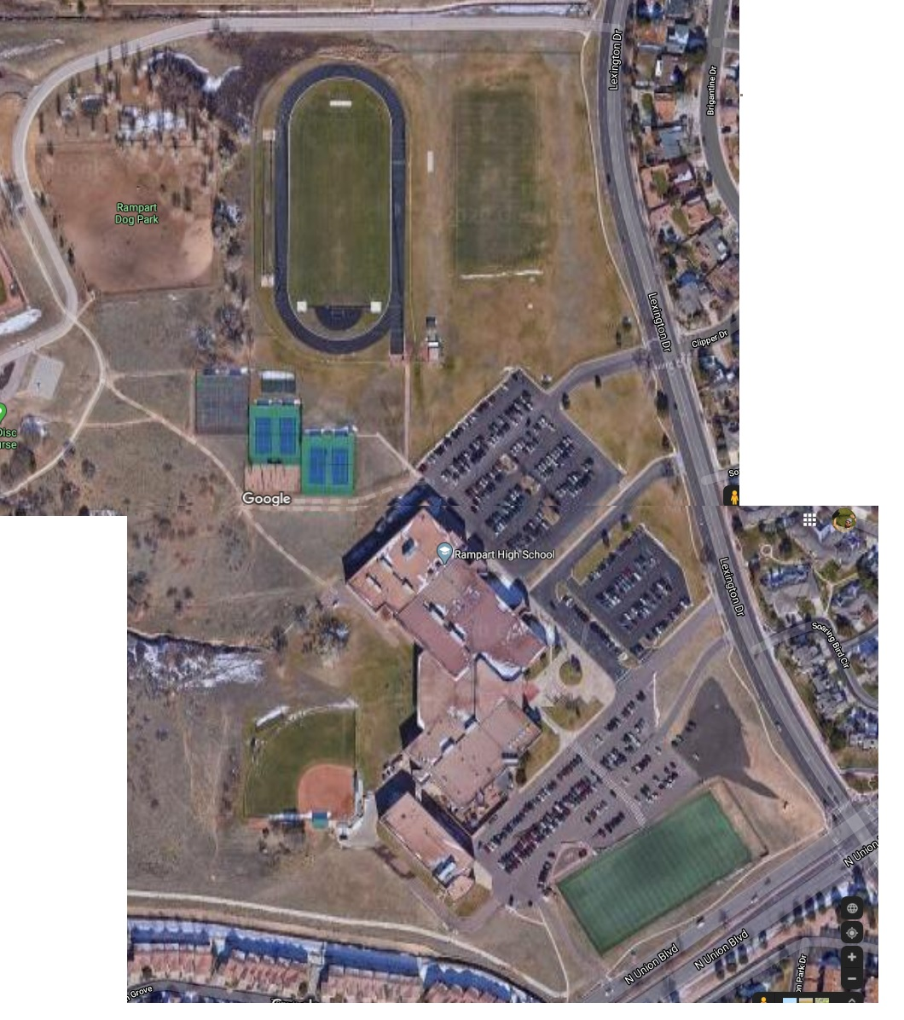

Mile 3 and .1

Mile 2

Mile 1

Finish

Start