Air Academy , Castle View, Chaparral, Cheyenne Mountain, Coronado, Discovery Canyon, Doherty, Elizabeth, Falcon, Fort Collins, Fountain-Fort Carson, Frontier Academy, Green Mountain, Harrison, Heritage, Liberty, Littleton, Lyons, Manitou Springs, Mitchell, Palmer, Palmer Ridge, Pine Creek, Poudre, Pueblo Central, Pueblo County, Rampart, Sand Creek, Sierra, Skyview, St. Mary`s, The Classical Academy, Thomas Maclaren Charter, Vista Ridge, Windsor, Woodland Park
2021 Spartan Invite
Friday October 1, 2021

2021 Spartan Invite
Welcome to the 17th Annual Spartan Invitational on Friday October 1, 2021 at Bear Creek Park East. Bear Creek East, 2002 Creek Crossing Street, Colorado Springs, CO 80905 (In Bear Creek Park Regional Park, SE of 21st & Rio Grande)
- Cost: $150 for one gender team or $300 for both boys and girls teams
- Entries are due at https://co.milesplit.com/meets/433332-doherty-spartan-cross-country-invitational-2021/info#.YOzaKOhKg2w Wednesday September 29, 2019, by 10:00pm MST. Online help on registering http://co.milesplit.com/pages/Online_Meet_Reg_Instructions . Entries only accepted on milesplit.com.
- Entries Password: Spartan 21
- Box Numbers Chosen by random number generator
- Scoring: Varsity run 7, score 5; Open race runs unlimited, displaces 7, score 5
- Timing: Victory Racing
- Chip Instructions: Chips must be LOOPED in shoelaces, ABSOLUTELY NOT FLATTENED. Remind athletes not running to stay clear of finish line mats, and well outside flagged area. Their chips will be picked up as a time and will hold up meet results.
- Directions: I-25 exit Cimarron/ Hwy 24 go West to 8th street. Turn South/ Left on 8th St. take 8th for a quarter mile. Turn West/ Right at Lower Gold Camp Road, take Lower Gold Camp for ½ mile. Turn left into the parking lot and following that to the West end of the parking lot. Or take Hwy 24 to 21st 1.5 miles . Turn left on 21st street go 1.1 miles to Rio Grande. East/Left on Rio Grande 0.1 miles.
- Team Camps: Canopies need to stay North of the garden and directly East of the garden. ABSOLUTELY NO CAMPS NEAR PARK OFFICE WEST OF CREEK CROSSING ROAD which includes any irrigated turf or around the park HQ office.
- Trainer will have tent near registration table.
- Changes/ adding runners will be done before 1:45pm at the scorer’s tent located at the finish line
- Parking is tight, but we do have fewer teams this year than years past. Car Pool if at all possible. Use the parking lots on the west side of 21st street up by sports fields.
  - BUS PARKING Busses will drop athletes off within the park then will leave the park to go to bus parking located in at Penrose Event Center Southwestern most parking area at 1045 Lower Gold Camp Road.
  - ACTIVITY BUS and Handicapped parking only within Bear Creek Park East, entering at Creek Crossing.
  - SPECTATORS park on West side of 21st at the athletic fields, Penrose equestrian center (walk Southwest from the parking lot to the race, 400 meters) , or in the neighborhoods North of the park. NO COST FOR PARKING
  - NO PARKING AT DOG PARK. NO SPECTATOR PARKING WITHIN THE PARK
- Coaches meeting at 2:00pm at the packet pick up area located at the West end of the garden parking lot.
- Restrictions:
  - No spectators or athletes in the community garden
- Awards: Top two teams in each division, T-shirt will be given to top ten Varsity Girls and top ten Varsity Boys, Ribbons to 11-20 Varsity, ribbons to top 20 in JV races.
- Meet Schedule
  - 2:30 p.m. Girls Open
  - 3:15 p.m. Boys Open
  - 3:45 p.m. Girls Varsity
  - 4:15 p.m. Boys Varsity
  - 5:00 p.m. Awards
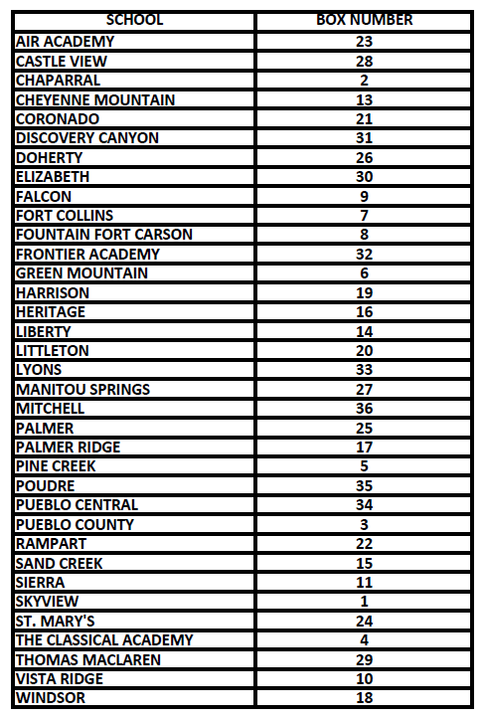
Meet Schedule
2:30 p.m. Girls Open
3:15 p.m. Boys Open
3:45 p.m. Girls Varsity
4:15 p.m. Boys Varsity
5:00 p.m. Awards

Course Map
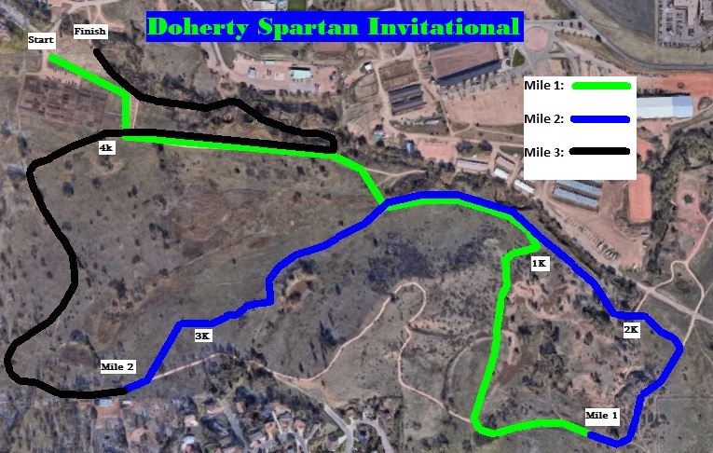

Parking Map
